PROJECT –1 : EXHAUSTIVE ANALYSIS OF INDIAN AGRICULTURE USING POWERBI

WEEK-1 TASK

In this project we are using power bi tool, it is a analytical and reporting tool and we are going to create a dashboard. In this project, we will analyse 19 years of Indian agriculture data to find various parameters of crop production, prediction based on past data and minimum support price for the given crop for the given year.

* First, we need to install power bi desktop, it is a product of Microsoft.

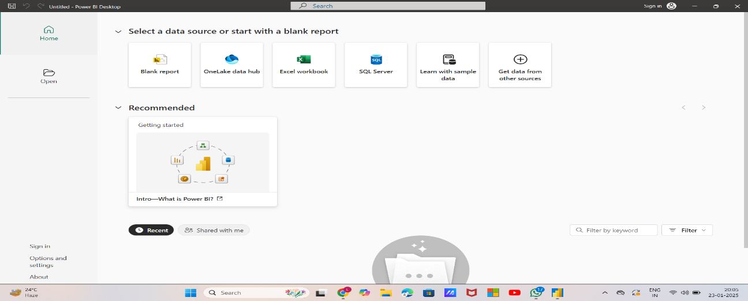

* This is the welcome window of power bi desktop.

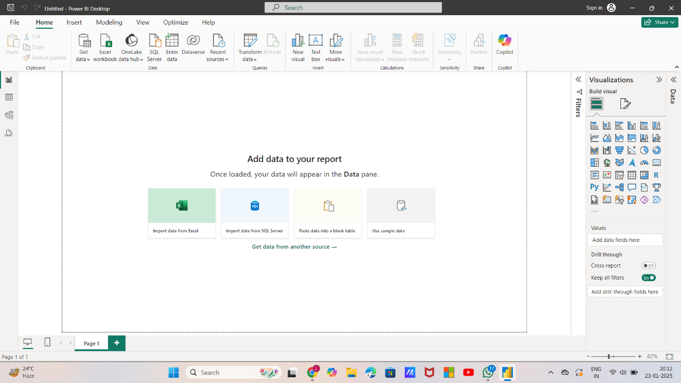

* Then we need to click on “Blank Report” , then it opens the power bi desktop, and on right hand side we can see certain visualizations and we call this particular scenario as canvas.

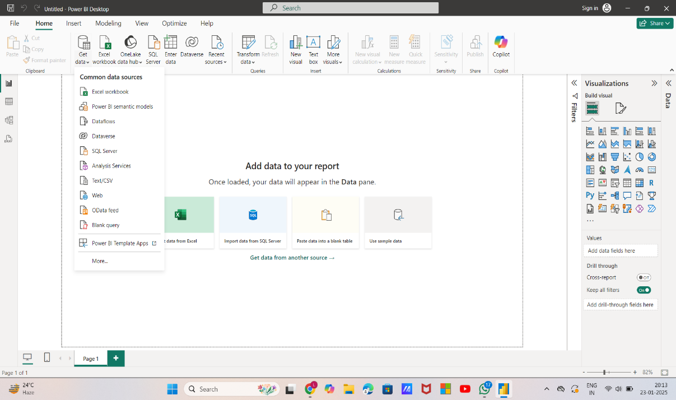

* Then click on “Get data” so that we get a dropdown with some options and from that options select “Text/CSV” as we are going to use the csv dataset .

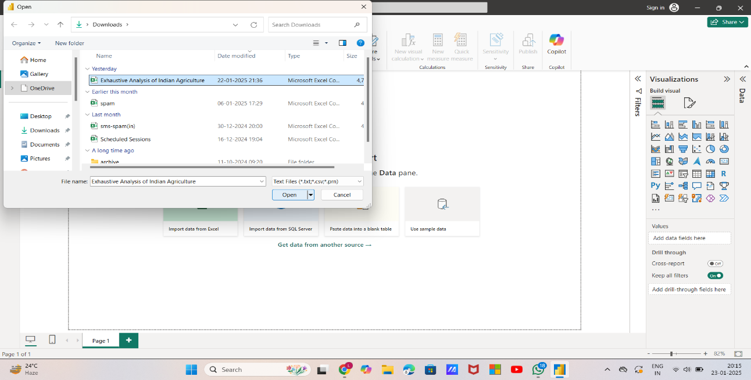

* After selecting “Text/CSV” a window is going to open , from that window we are going to select the dataset required for our project.

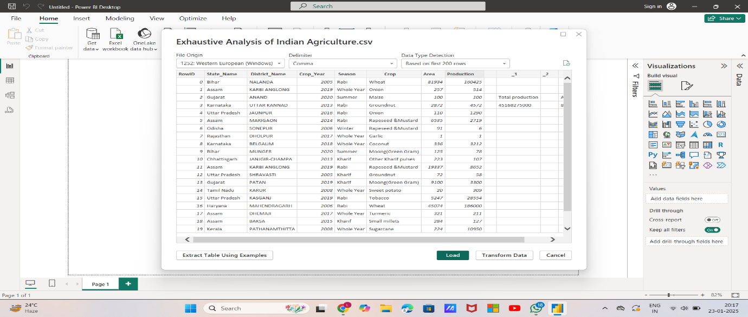

* After selecting the dataset, it will show the overview of our data and it is also showing three buttons such as Load, Transform and Extract. Load is used when your data is cleaned and transformed is used when you want to process the data. Now click on “Load”.

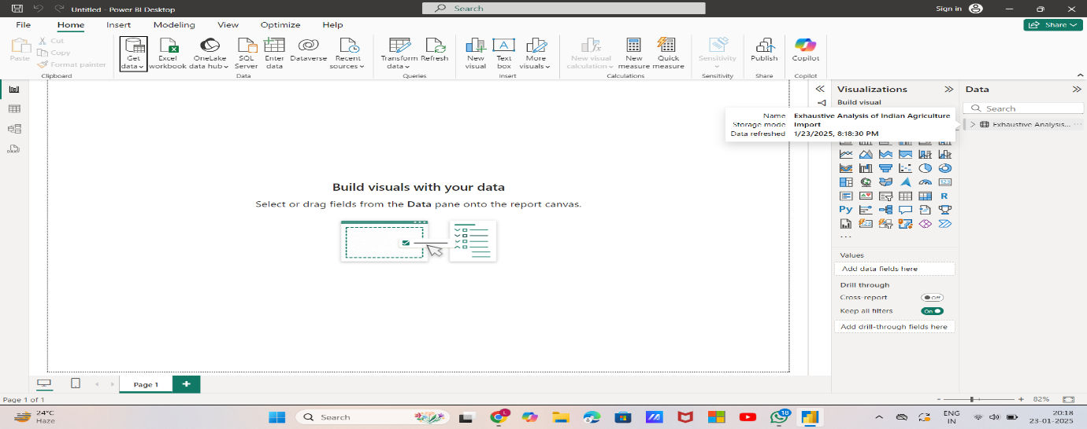

* After clicking on “Load” at the right side we can see that the data is loaded.

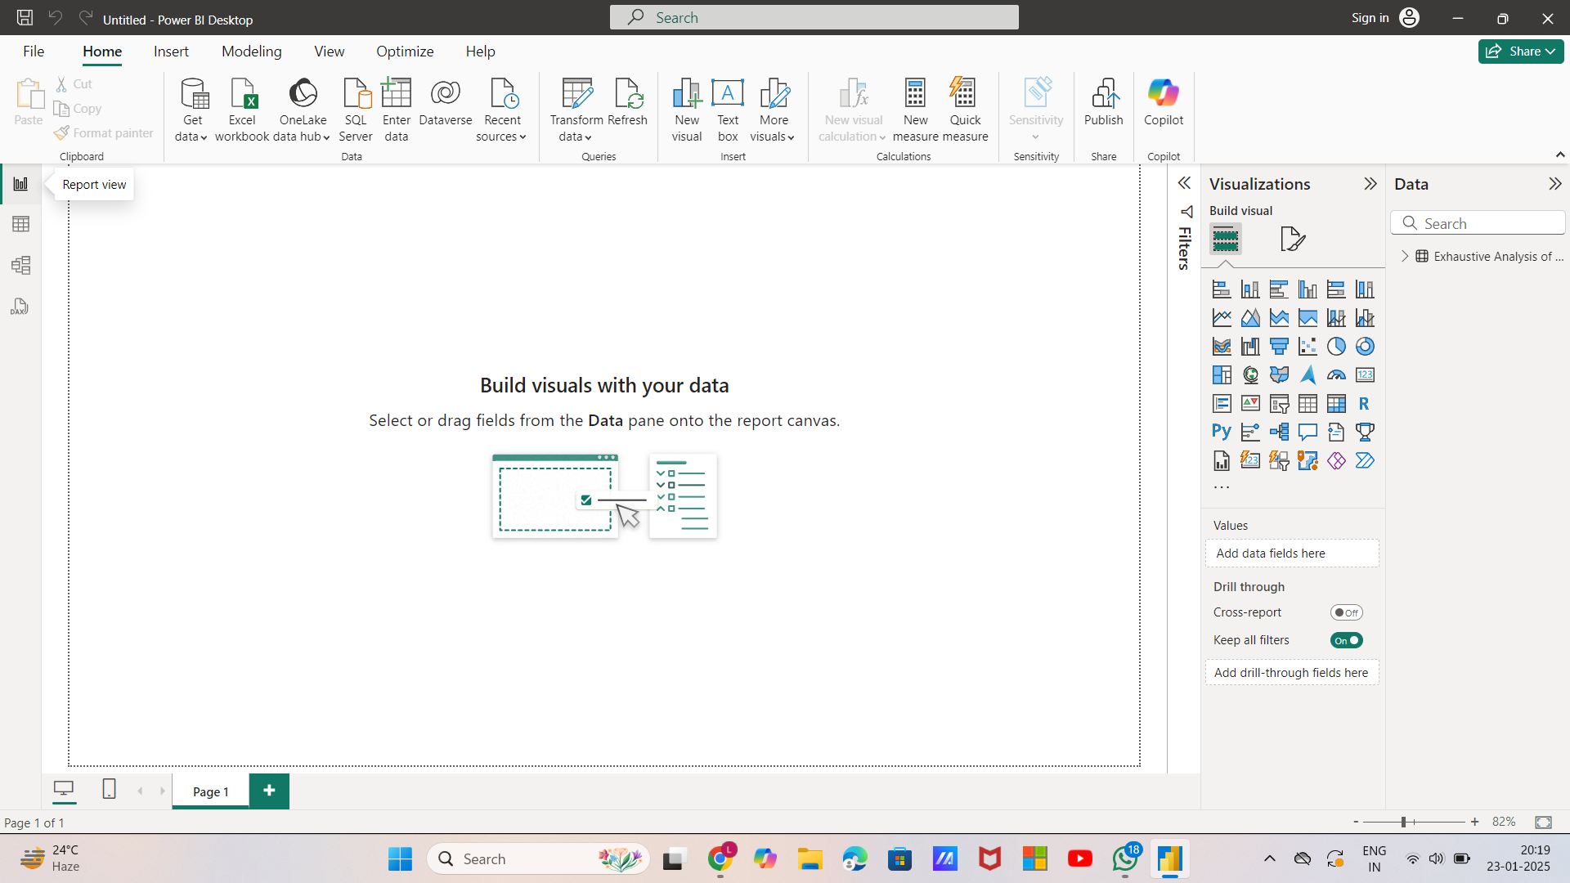

* At left hand side we can see small icons , in that first one is Report View. In Report view we perform all visualisation.

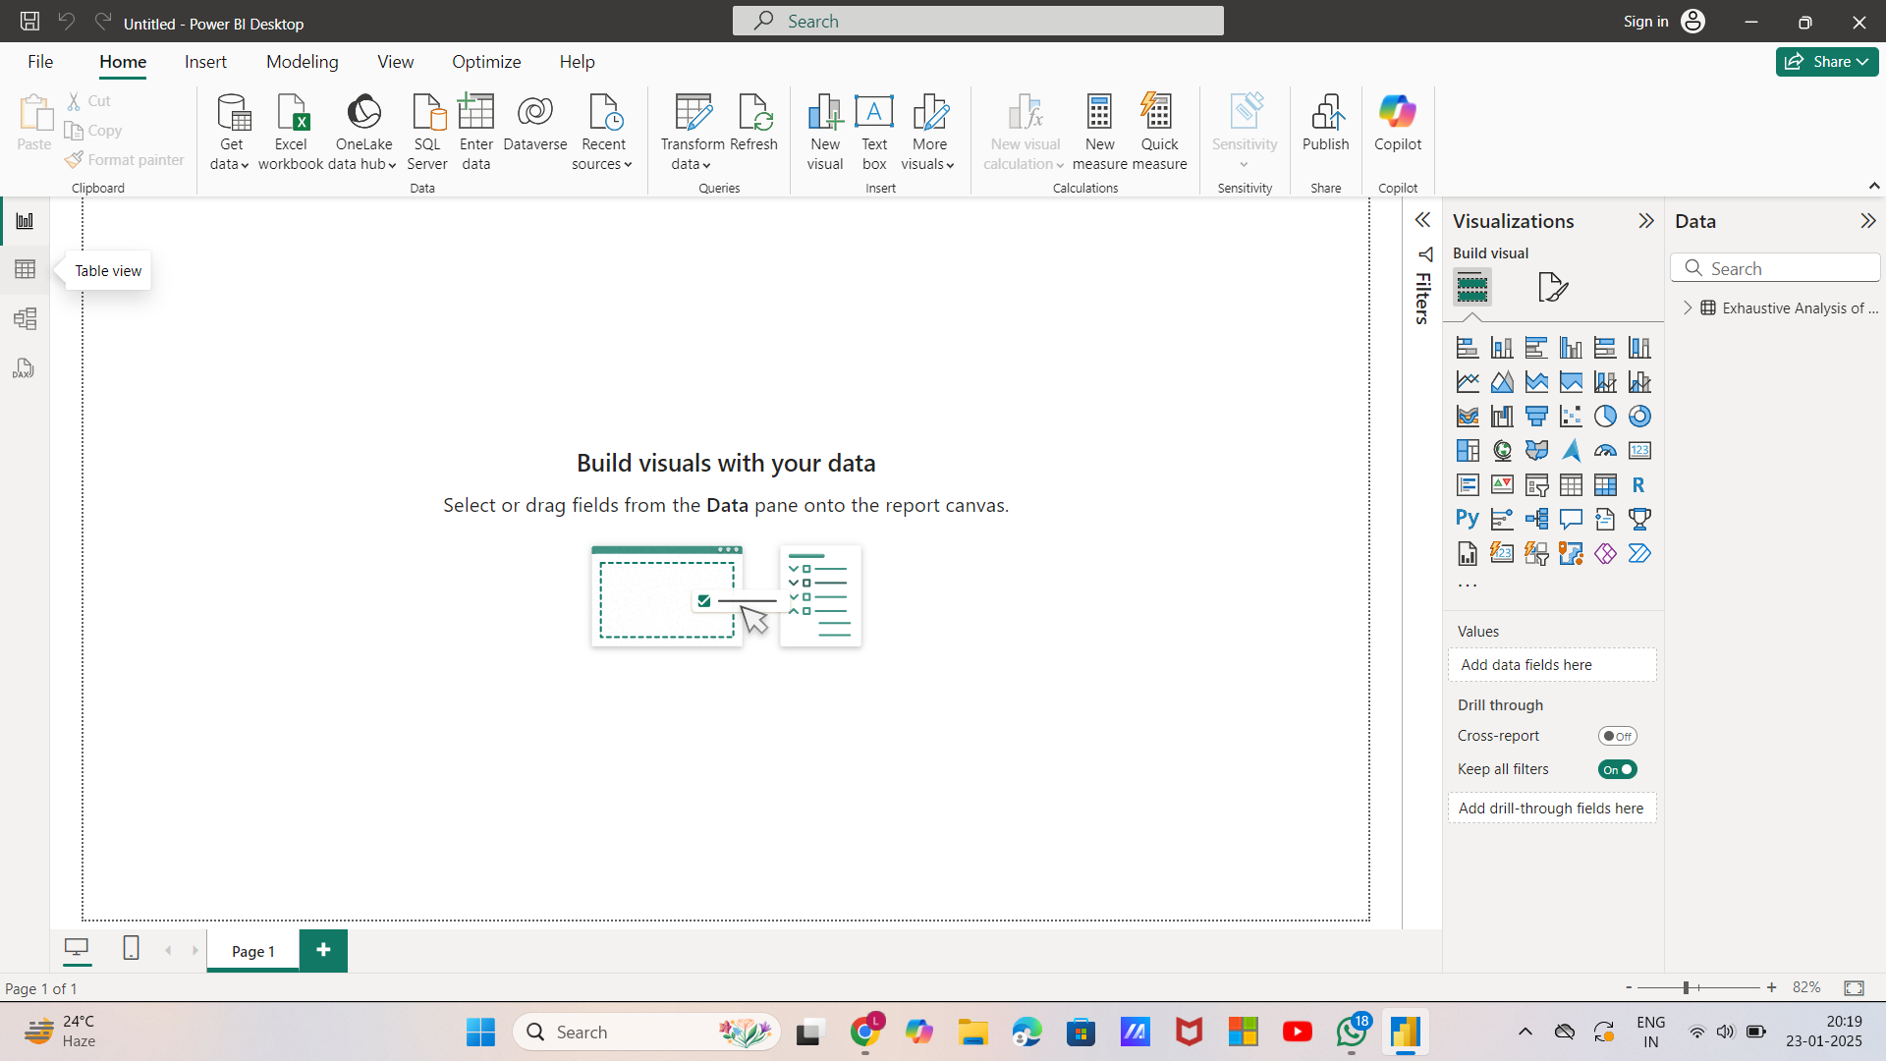

* The second icon is Table view, in Table View we will get the overview of the data.

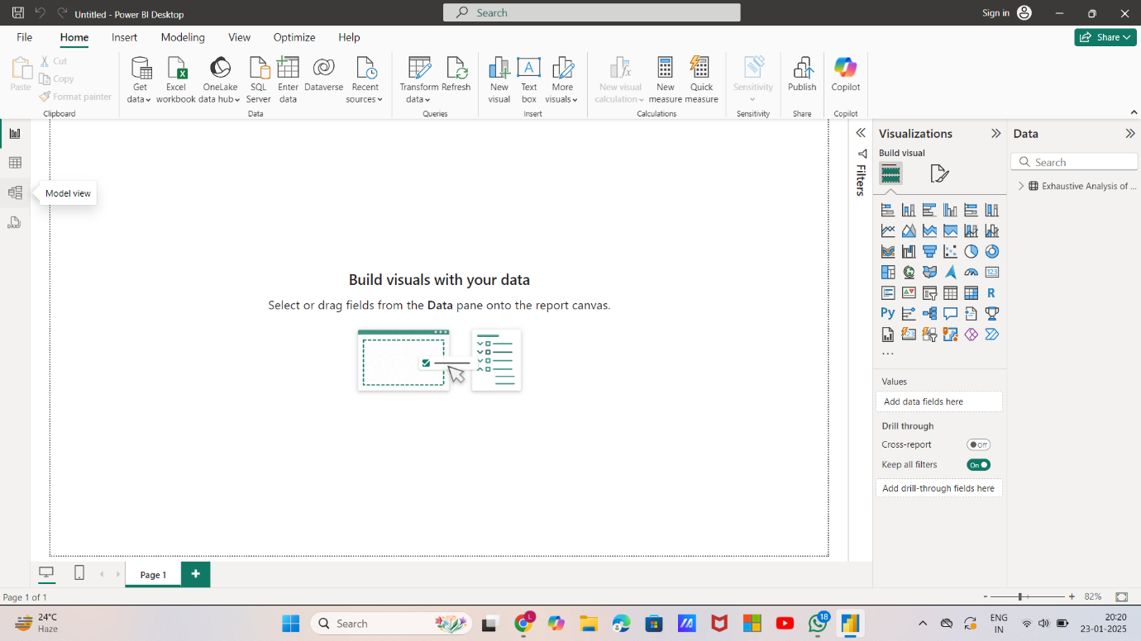

* The third view is Model View, in Model View we can create relationship among data.

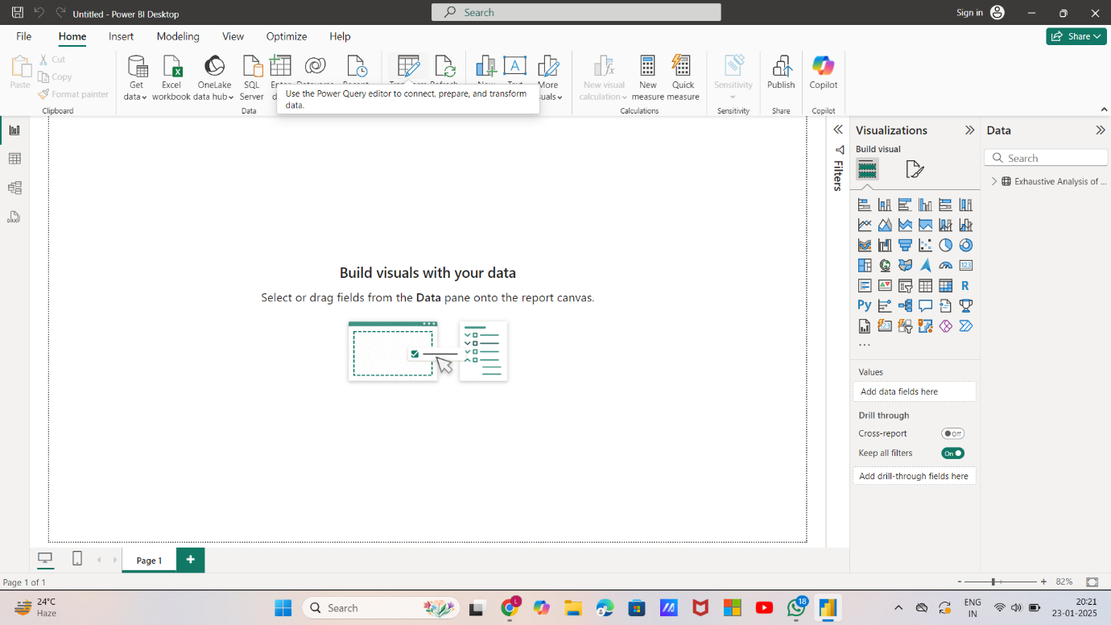

* Now we can transform the data by clicking on Transform Data shown as above. So that a new window is going to open.

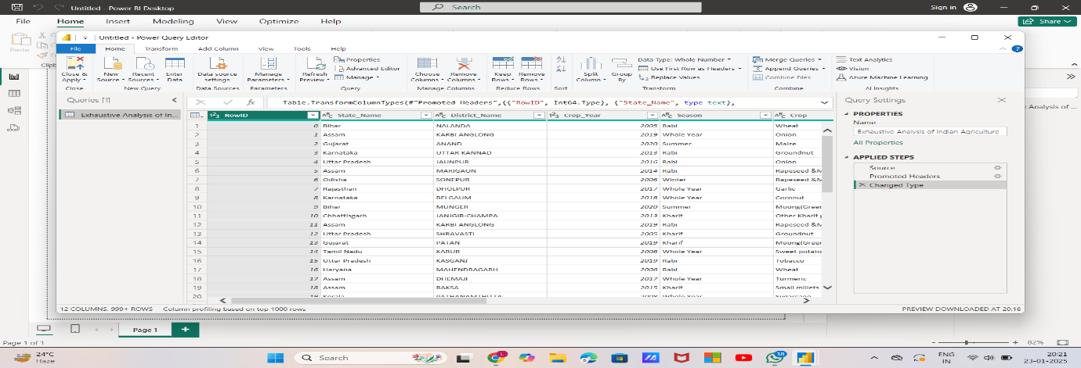

* This window is called as Power Query Editor, in this editor we can do all the cleaning process. We can see some kind of buttons in this window as Keep Rows, Remove Columns, Replace values, etc. We can do all the transformation by using this power query editor.

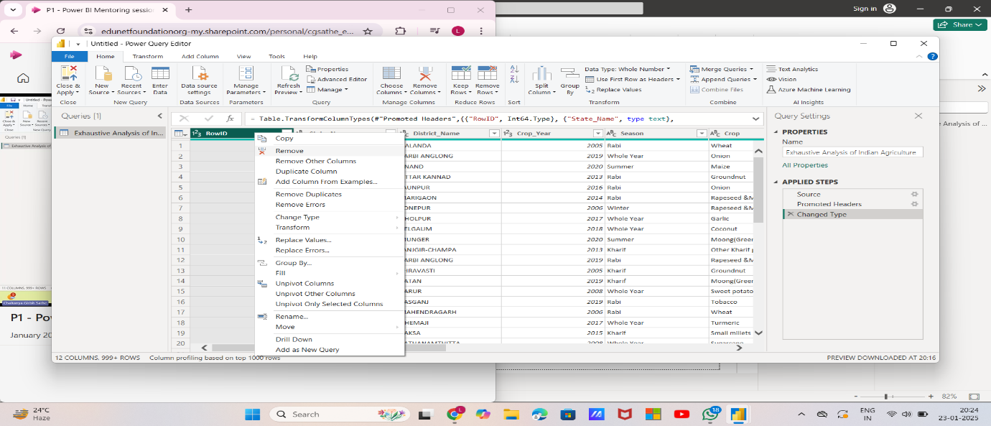

* We can remove the blank and unnecessary columns by doing right click at the column that we want remove and select Remove option from the dropdown. After removing the columns then that is added at the right side on Applied Steps box.

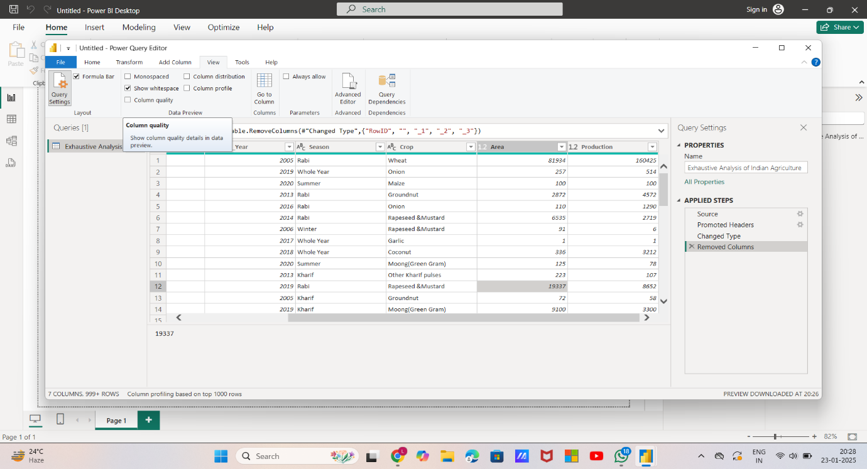

* To check whether the data contains null values or not, we need to click on VIEW tab at the top and in that select “Column Quality” as shown above.

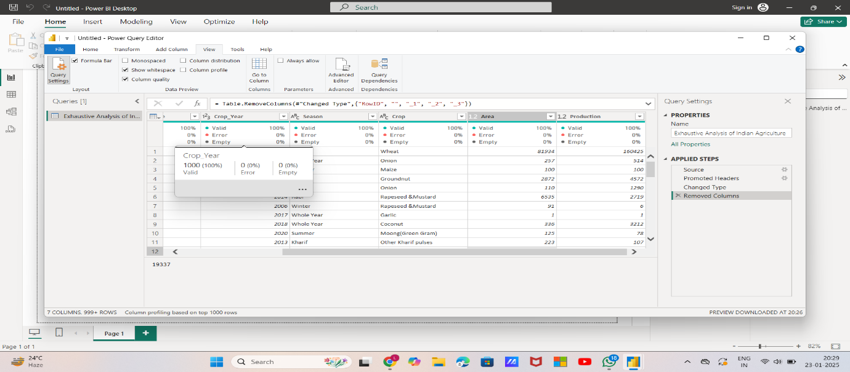

* After clicking on Column Quality , we come to know whether there are any null values or not. We can see a small box under the column names , in that we can see how much empty values are present , in this it is 0% means there is no empty value.

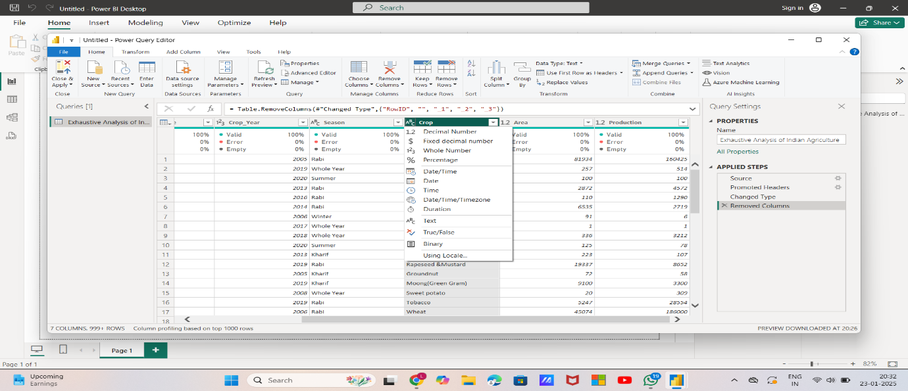

* At the column name we can see as 123 and as ABC , by clicking on that we can see the different datatypes.

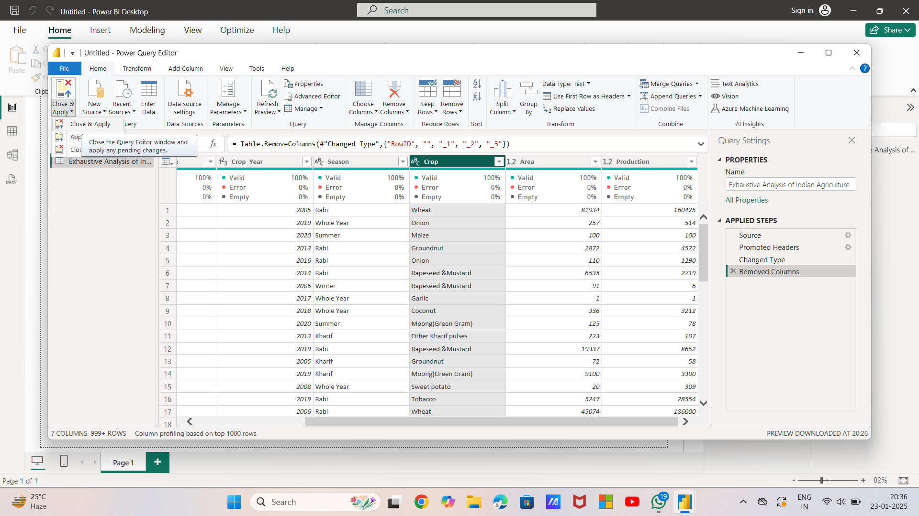

* The things that we are implemented till now need to be saved. So for saving go the HOME tab , we can see the option CLOSE & APPLY, select that and click on “close & apply” button. This need to be done because the changes that are made till now will be reflected on power bi desktop. Then it takes certain time to load that.

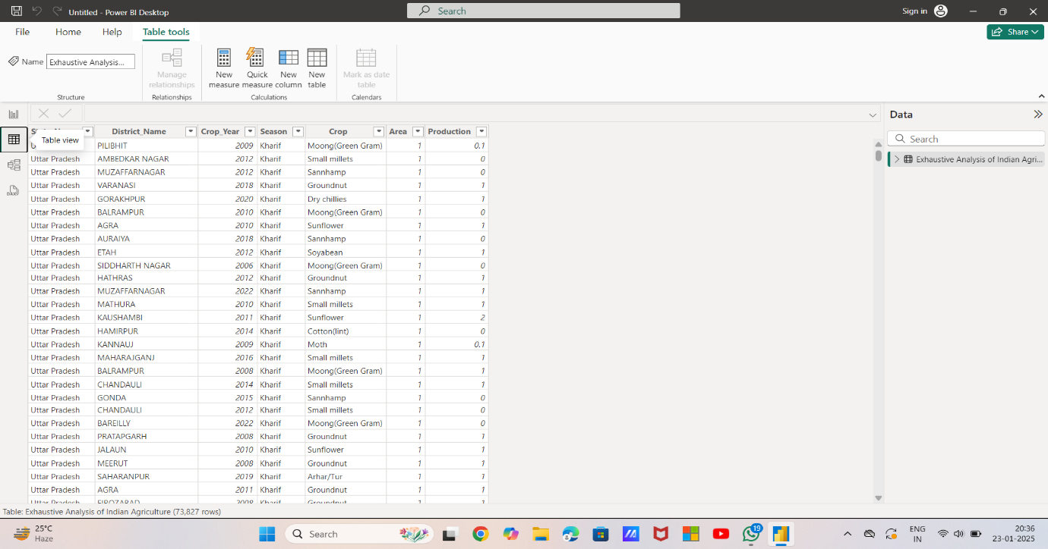

* After that click on Table View on power bi desktop, then we can see only the required data , not the unnecessary columns because we selected close & apply button.

This is the week1 task. Submitted by L.Likhitha